Module 3: IAM Roles Assignment
Problem Statement:
You work for XYZ Corporation. To maintain the security of the AWS account and the resources you have been asked to implement a solution that can help easily recognize and monitor the different users.
Tasks To Be Performed:
1. Create a role which only lets user1 and user2 from task 1 to have complete access to VPCs and DynamoDB.
2. Login into user1 and shift to the role to test out the feature.

1.Creating the role for VPC and DynamoDB access:
- Choosing trust policy:
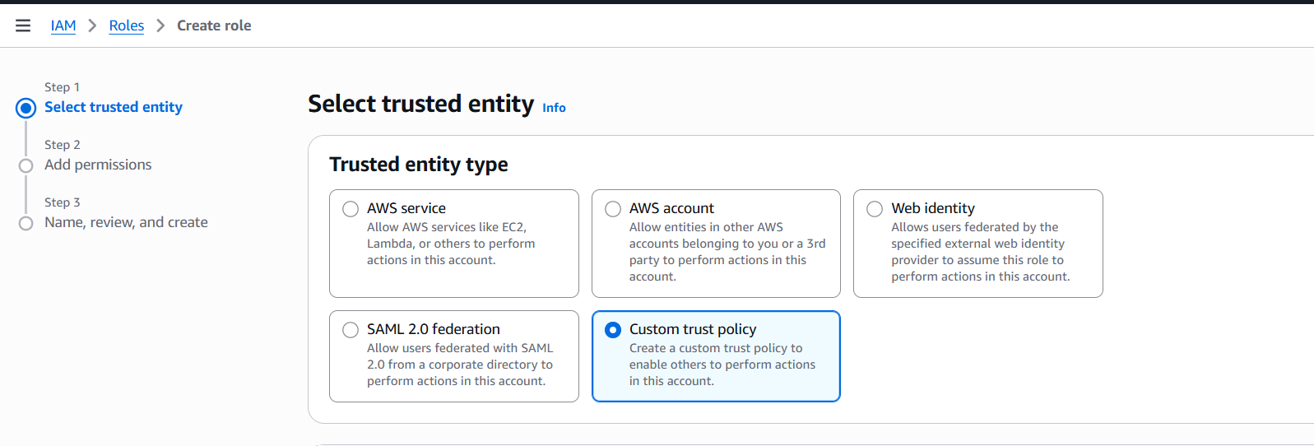
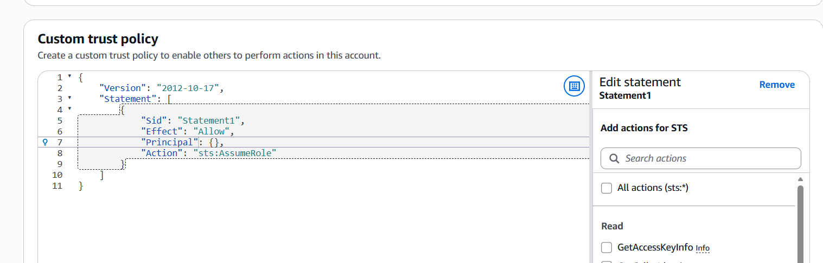
- Copying user’s ARN:
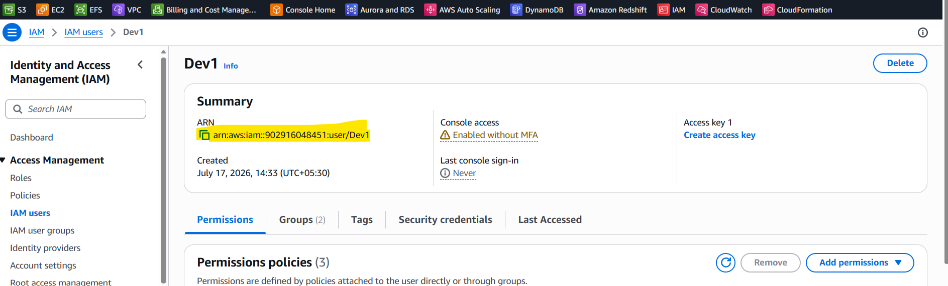
- Paste the user’s ARN in the principal column:
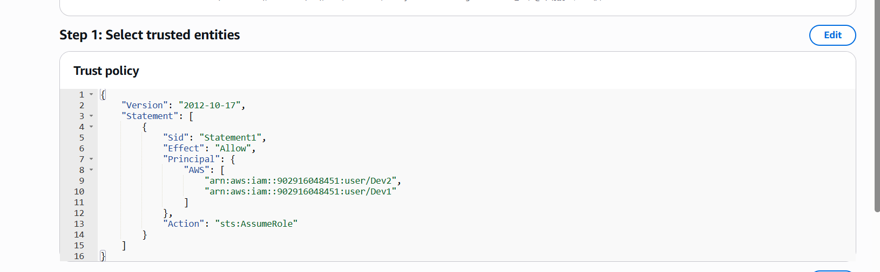
- Choosing VPC and DynamoDB permissions:
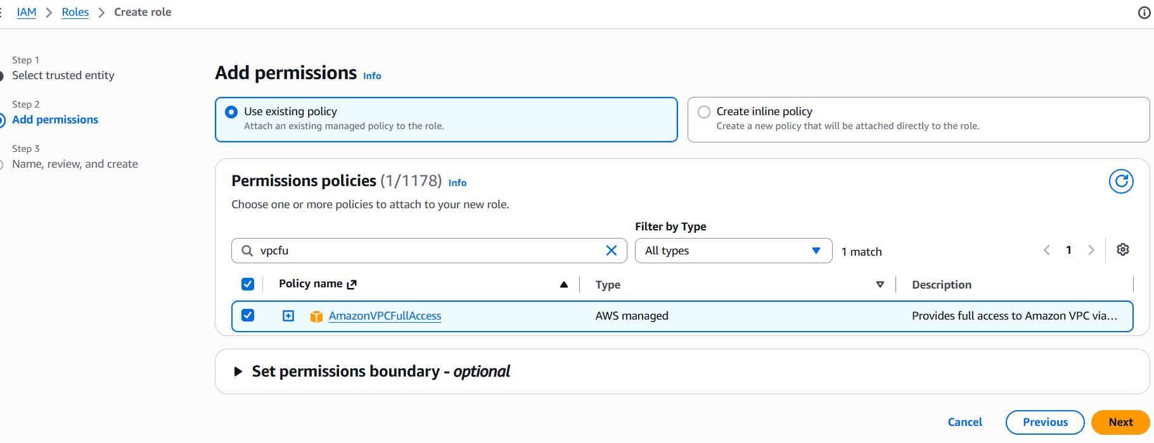
- Mention the role name: module3-roles
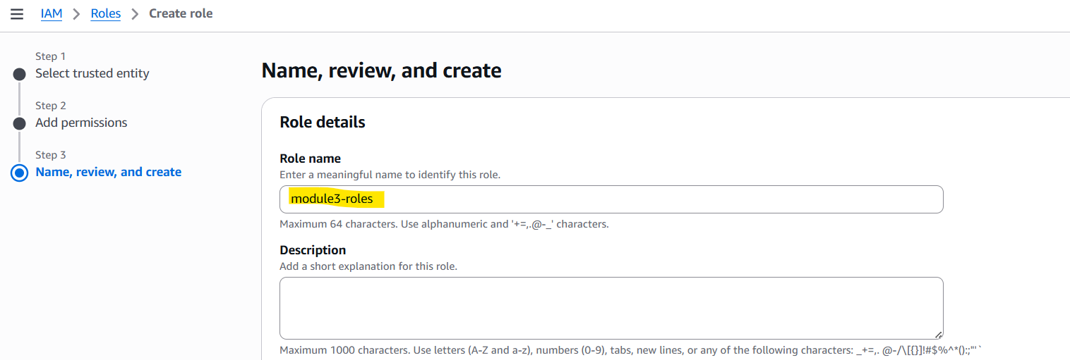
- Role module3-roles created:
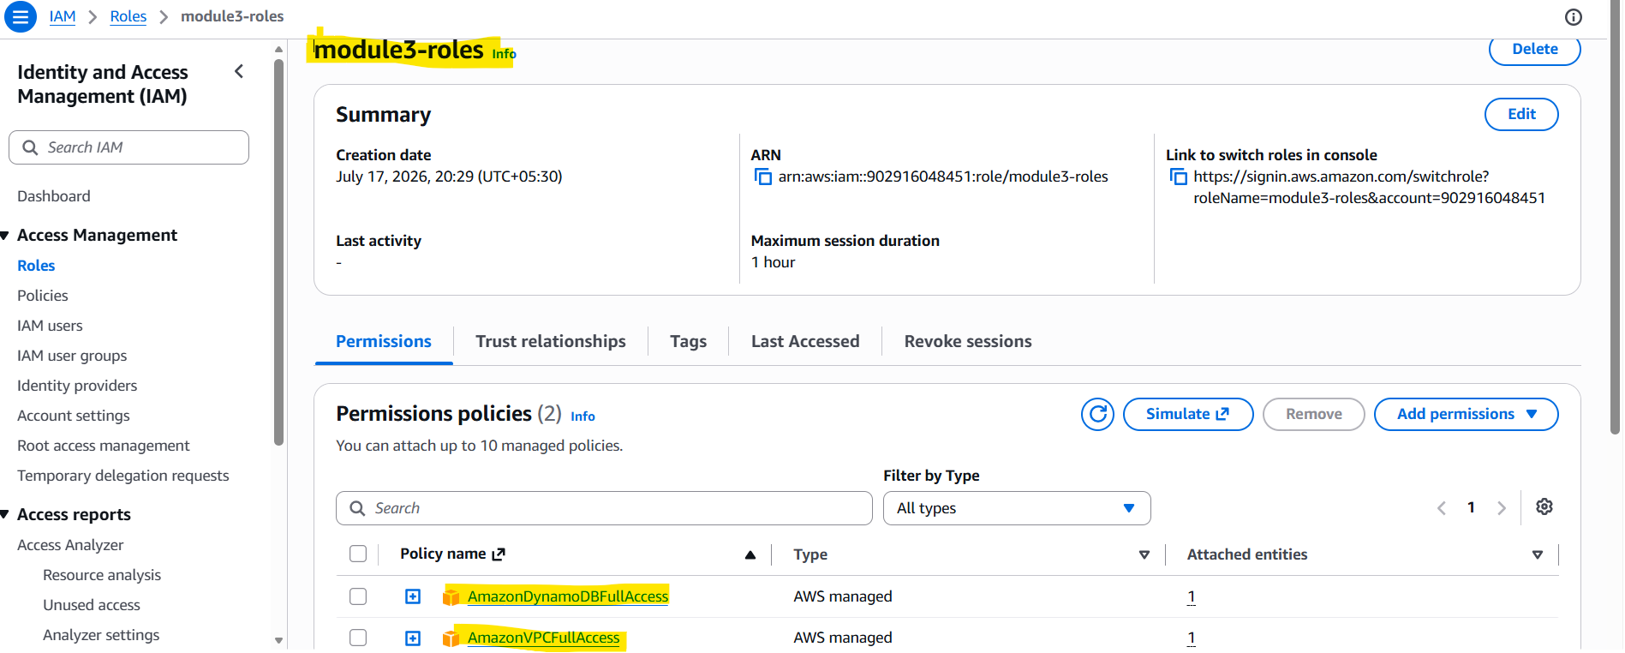

2. Login into user1 and shift to the role to test out the feature.
A. Login as Dev1 user and select switch role under the ID:
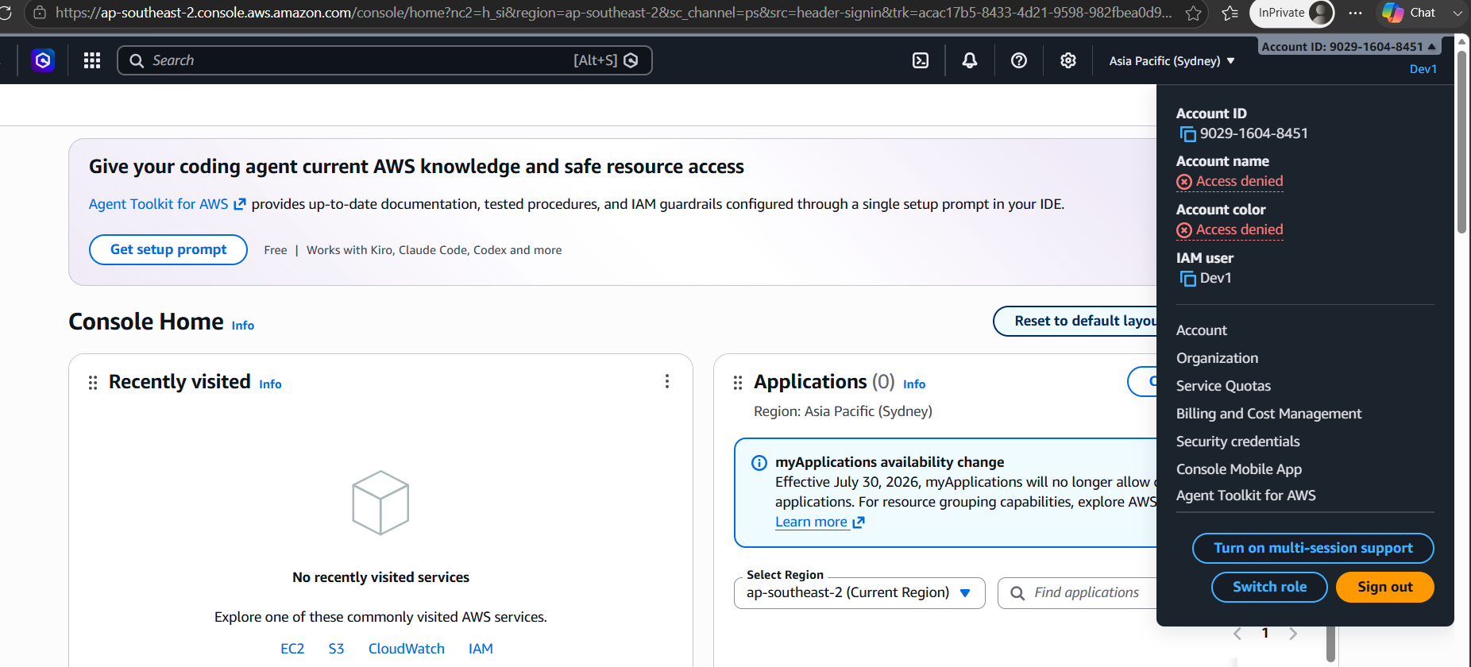
B. Provide the Account ID and role name:
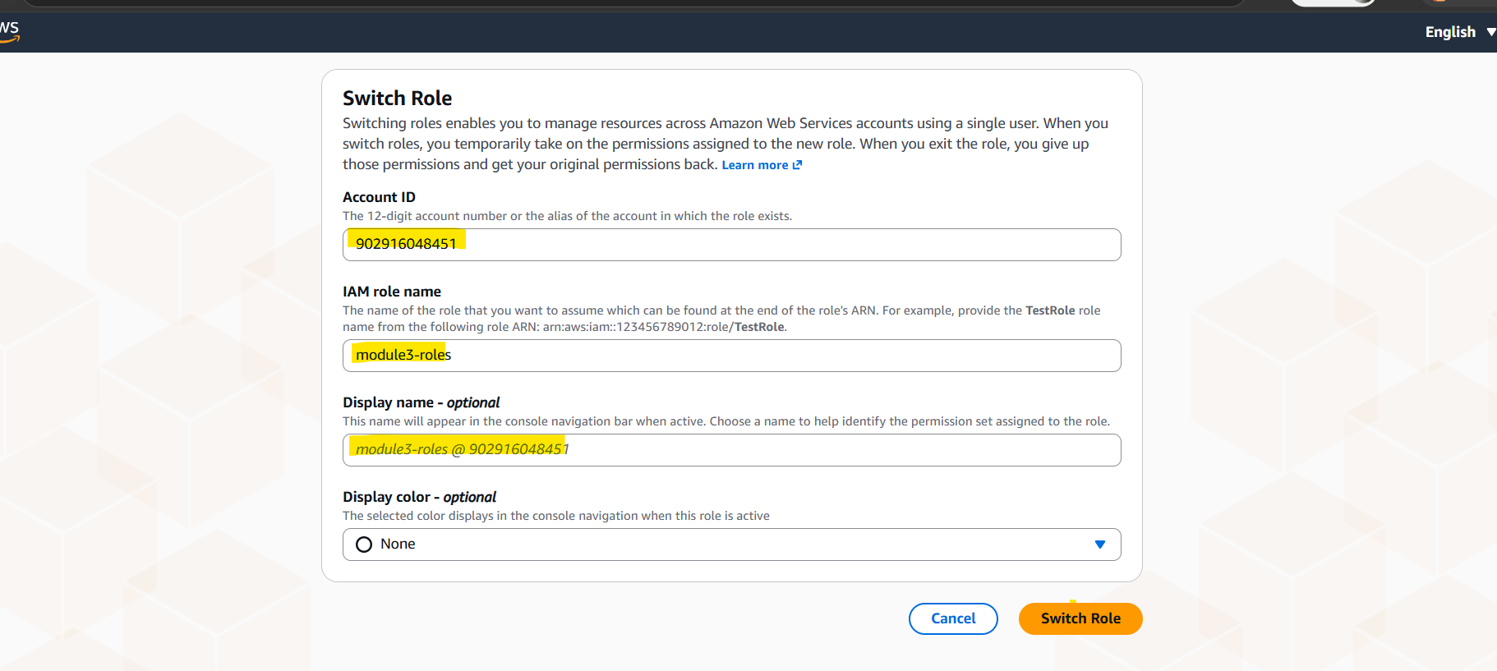
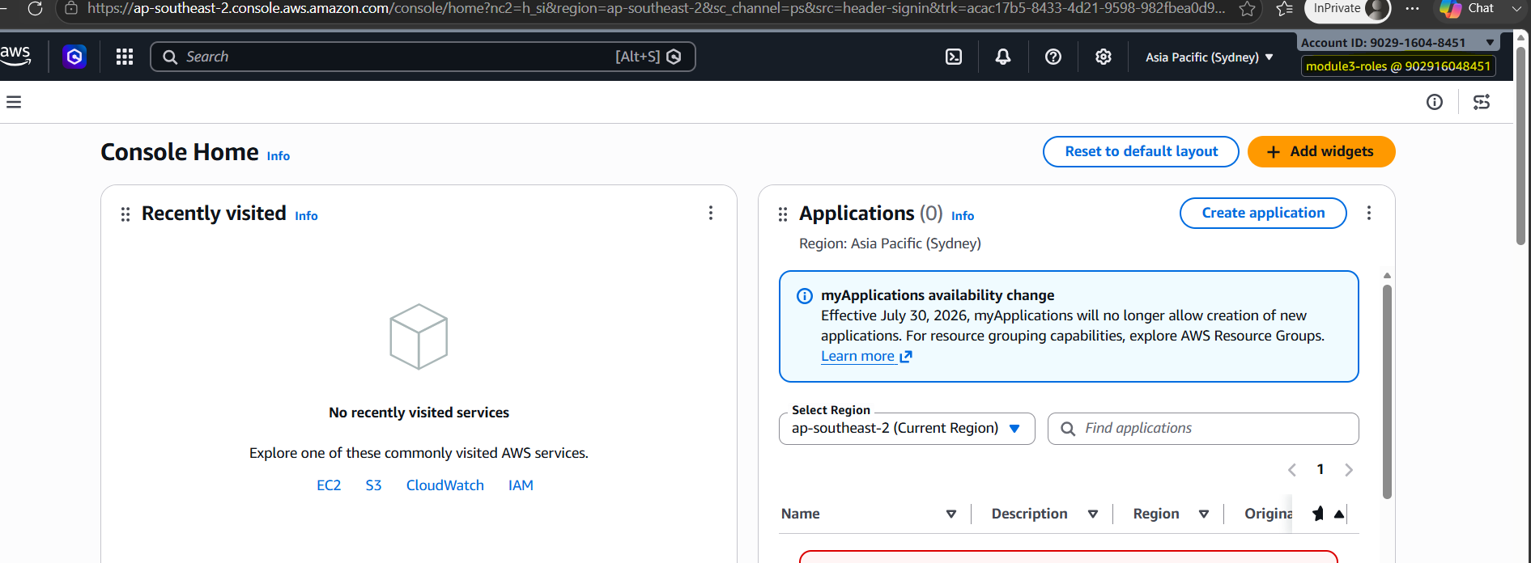

C. Validating the DynamoDB access:
Create the table:
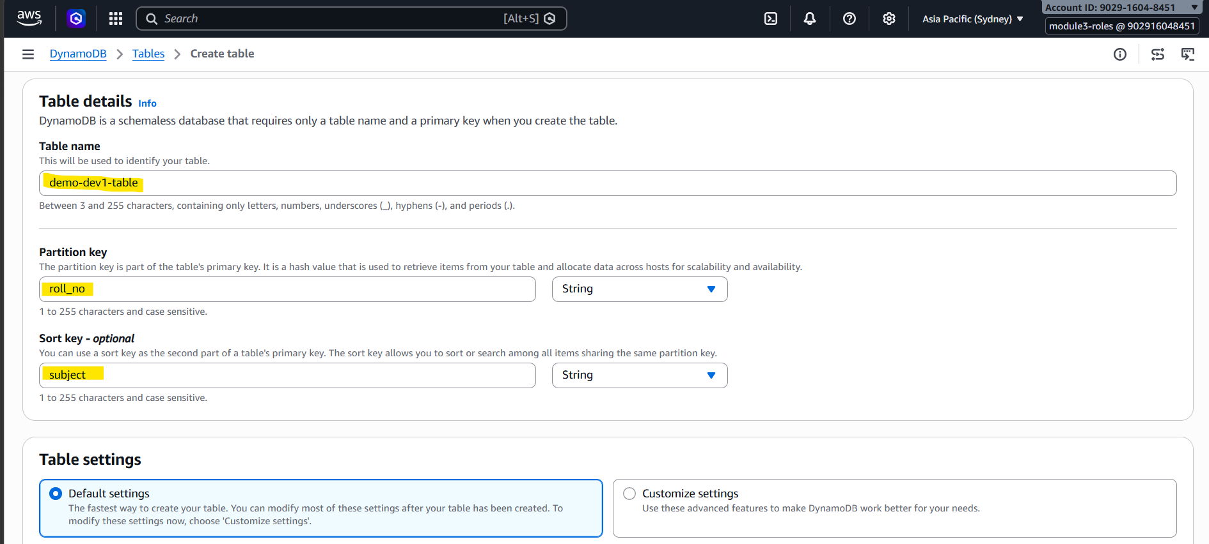
Table created:
